

**Project Title:**

**A Secure and Intelligent Banking System**

**with Fraud Detection**

|  |  |  |
| --- | --- | --- |
| **Name** | **Reg Number** | **Contribution** |
| Muhammad Abubakar | 2023352 | Backend, Integration |
| Muhammad Afeef Bari | 2023356 | Frontend, Report |
| Muhammad Ismail | 2023452 | Frontend, Slides |
| Shayan Siddiqui | 2023656 | Backend, Integration |

**1. Project Overview**

Bakri Pay is a comprehensive, secure, and modular online banking platform developed as a Database Management Systems project. The system simulates real-world banking operations while incorporating advanced fraud detection, robust user authentication, and a polished frontend for enhanced user experience. Built using Flask (Python) and a layered MVS architecture, it emphasizes scalability, security, and modularity. The project aims to address common challenges in traditional banking systems, including fragmented architecture and weak fraud detection, providing a modern, user-friendly, and secure banking solution

**2. Technology Stack:**

**Front End:** Python 3.11, Flask 2.x

**Back End:** HTML5, CSS3, JavaScript (Vanilla)

**Database:** SQLite (development), MySQL (scalable deployment)

**Project Managment:**

**Code Hosting:** Replit

**Authentication:** Flask-Login, environment-based config, OTP-based 2FA, role-based access control

**3. Entity-Relationship Diagram (ERD)**

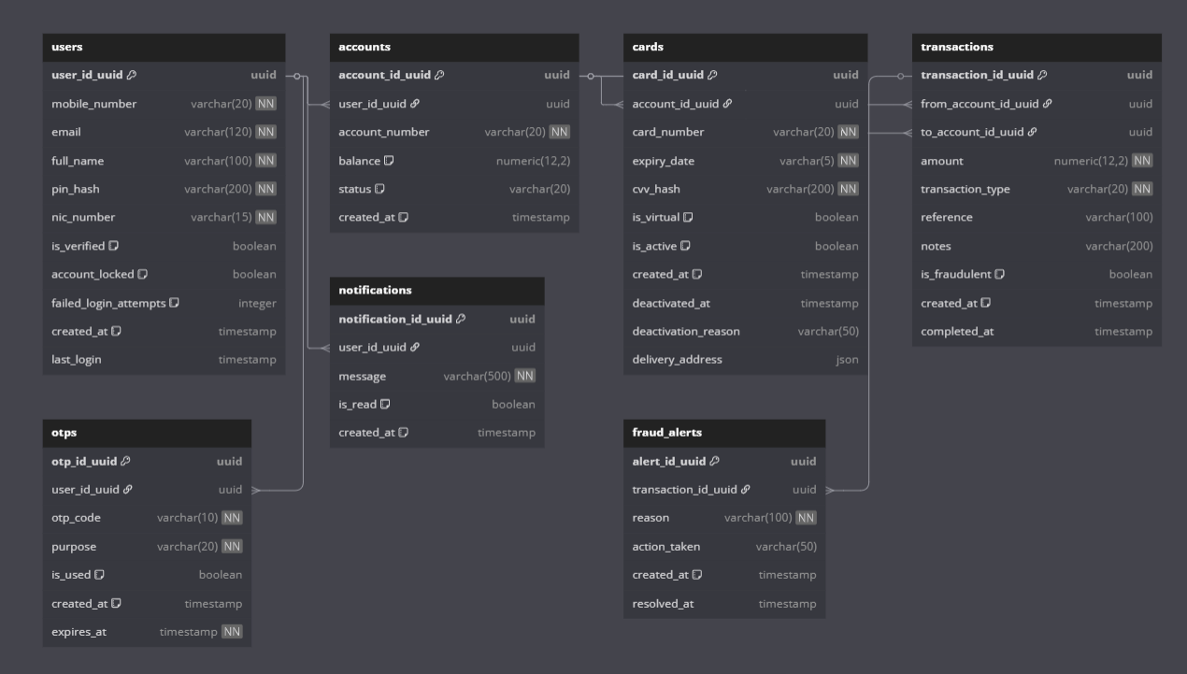

**4. Database Schema (Simplified)**

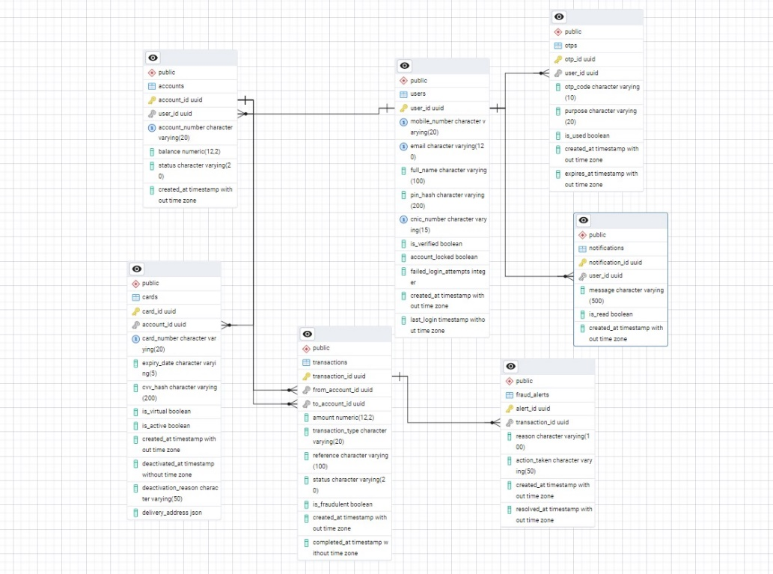

**5. Screenshots of Working System**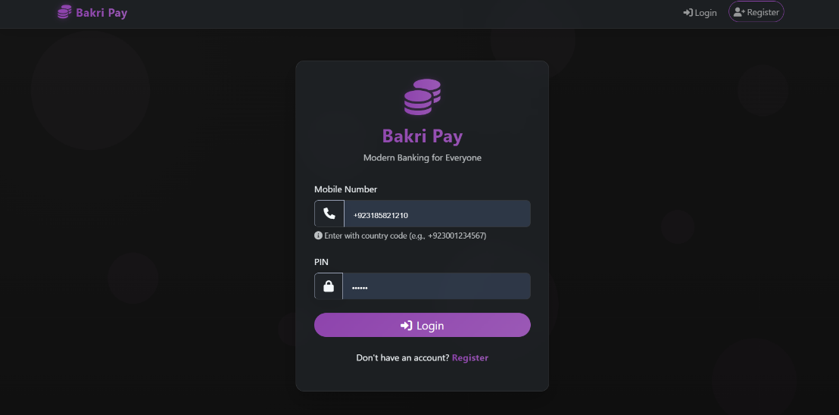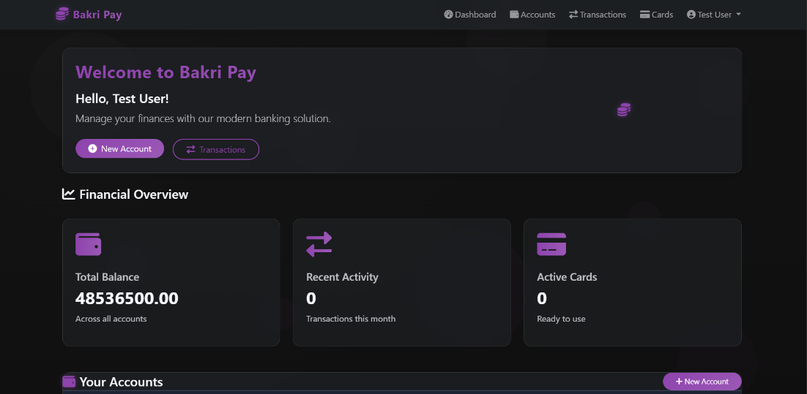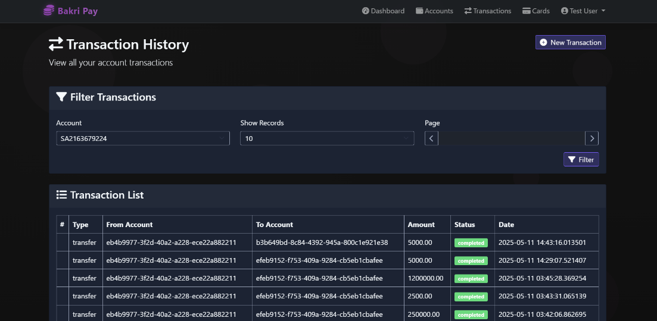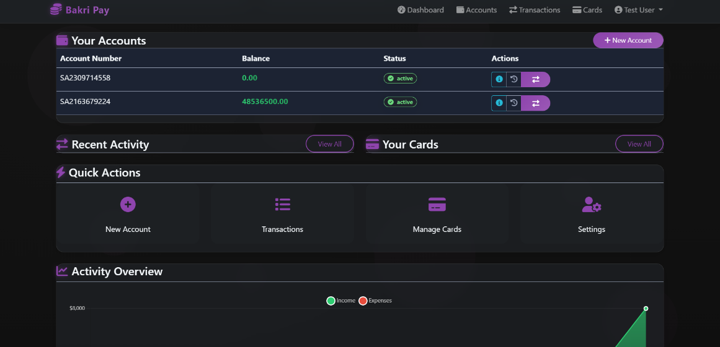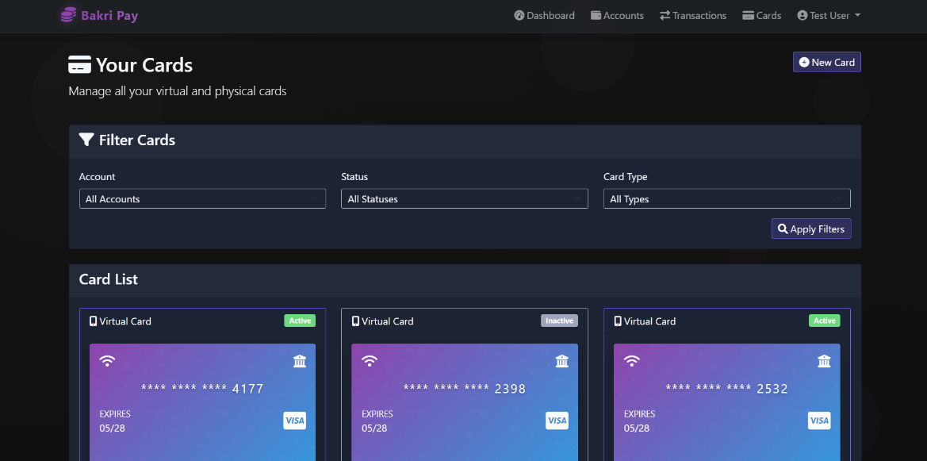

**6. Functionalities Implemented**

1. **User Authentication & Authorization:** Secure registration, login, password encryption, OTP verification, and session management.
2. **Account Management:** Account creation, deletion, balance inquiry, and detailed account summaries.
3. **Card Management:** Virtual card generation, card blocking, and secure card data handling.
4. **Transaction Processing:** Real-time transfers, transaction history, overdraft protection, and notification hooks.
5. **Fraud Detection:** Rule-based anomaly detection with real-time transaction monitoring and alerting.
6. **OTP and Notifications:** Secure, expirable OTPs for sensitive actions and real-time notifications.
7. **Utility Services:** Data sanitization, error handling, and form validation for enhanced security.
8. **Bills and Additional Services:** Utility bill payments and service provider management (beta version).

**7. GitHub Details**

https://github.com/shayan1278/A-Secure-and-Intelligent-Baking-System-with-Fraud-Detection-

**8. Challenges Faced**

1. **Security Integration:** Implementing layered security without compromising user experience.
2. **Modular Design:** Maintaining code modularity while ensuring seamless service integration.
3. **Scalability:** Balancing lightweight development with future scalability needs.
4. **Fraud Detection Complexity:** Designing effective anomaly detection with minimal false positives.
5. **Database Optimization:** Efficient database design to handle high transaction volumes without lag.
6. **Cross-Module Communication:** Coordinating data flow across multiple modules without introducing bottlenecks.

**9. Future Enhancements**

* AI-based fraud detection using user pattern clustering
* Mobile application (Flutter/React Native)
* Real-time analytics dashboard
* Biometric integration and adaptive security

**10. Conclusion**

Bakri Pay successfully simulates a real-world banking platform with a strong emphasis on security and user experience. The project demonstrates the power of modular software architecture, making it a valuable academic exercise and a potential blueprint for future financial technology solutions. The incorporation of fraud detection, OTP-based authentication, and modular service components highlights the team's focus on building a secure and scalable banking system.